**JUNIT TEST**

**11. REVERSE A WORD**

**package** proggrammingknowledge;

**public** **class** Stringreverse {

**public** String reverse(String input) {

**if** (input == **null**) {

**return** input;

}

String output = "";

**for** (**int** i = input.length() - 1; i >= 0; i--) {

output = output + input.charAt(i);

}

**return** output;

}

}

package proggrammingknowledge;

import static org.junit.jupiter.api.Assertions.*;

import org.junit.jupiter.api.Test;

class Stringreversee {

@Test

void testStringreversee() {

Stringreverse example = new Stringreverse();

assertEquals("tac", example.reverse("cat"));

assertNull(example.reverse(null));

assertEquals("", example.reverse(""));

}

}

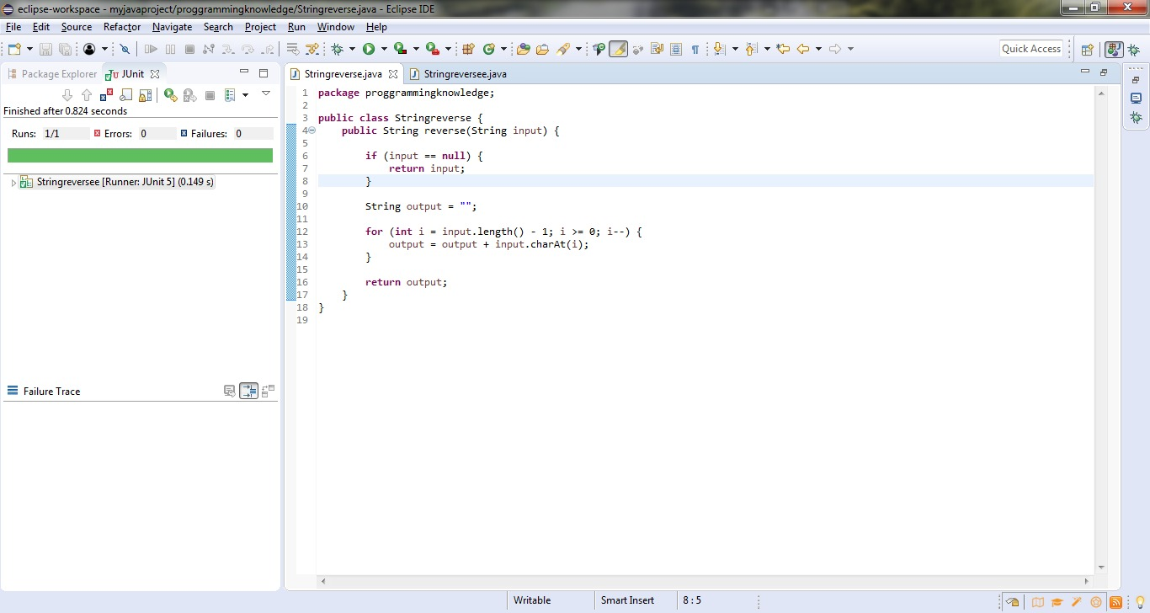

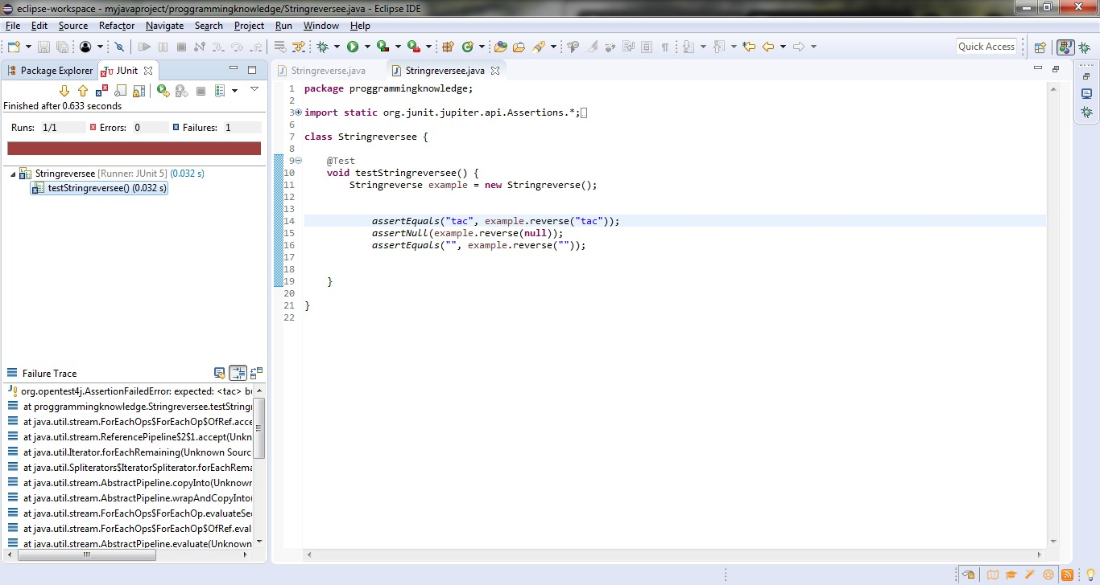

**12. String compare**

**package** proggrammingknowledge;

**public** **class** Stringcompare {

**public** **void** compareStrings(String str1, String str2) {

**if** (str1.equals(str2)) {

System.***out***.println("Strings are equal.");

} **else** {

System.***out***.println("Strings are not equal.");

}

}

**public** **static** **void** main(String[] args) {

String str1 = "Hello";

String str2 = "hello";

Stringcompare comparer = **new** Stringcompare();

comparer.compareStrings(str1, str2);

}

}

package proggrammingknowledge;

import static org.junit.jupiter.api.Assertions.*;

import org.junit.jupiter.api.Test;

class Stringcomparee {

@Test

void testStringcomparee() {

String str1 = "Hello";

String str2 = "Hello";

assertEquals(str1,str2);

}

}

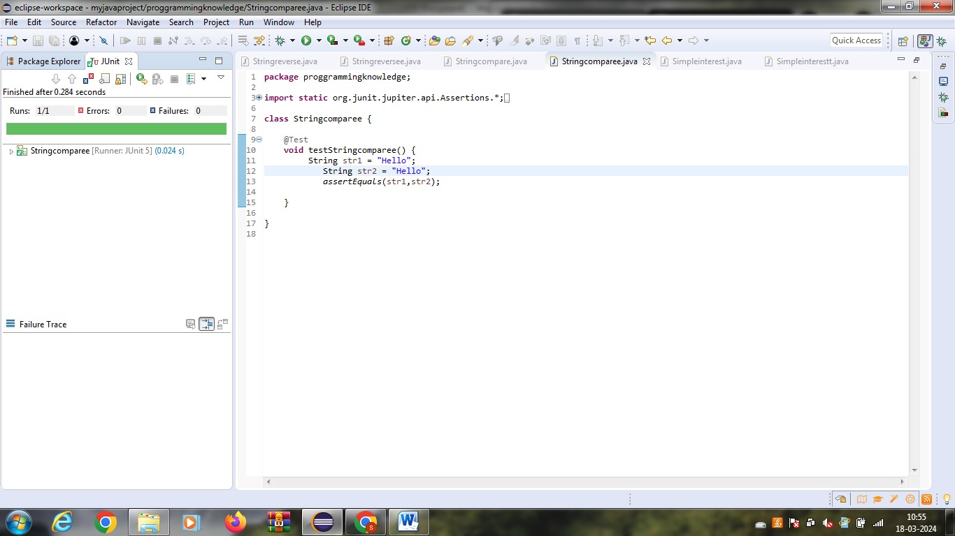

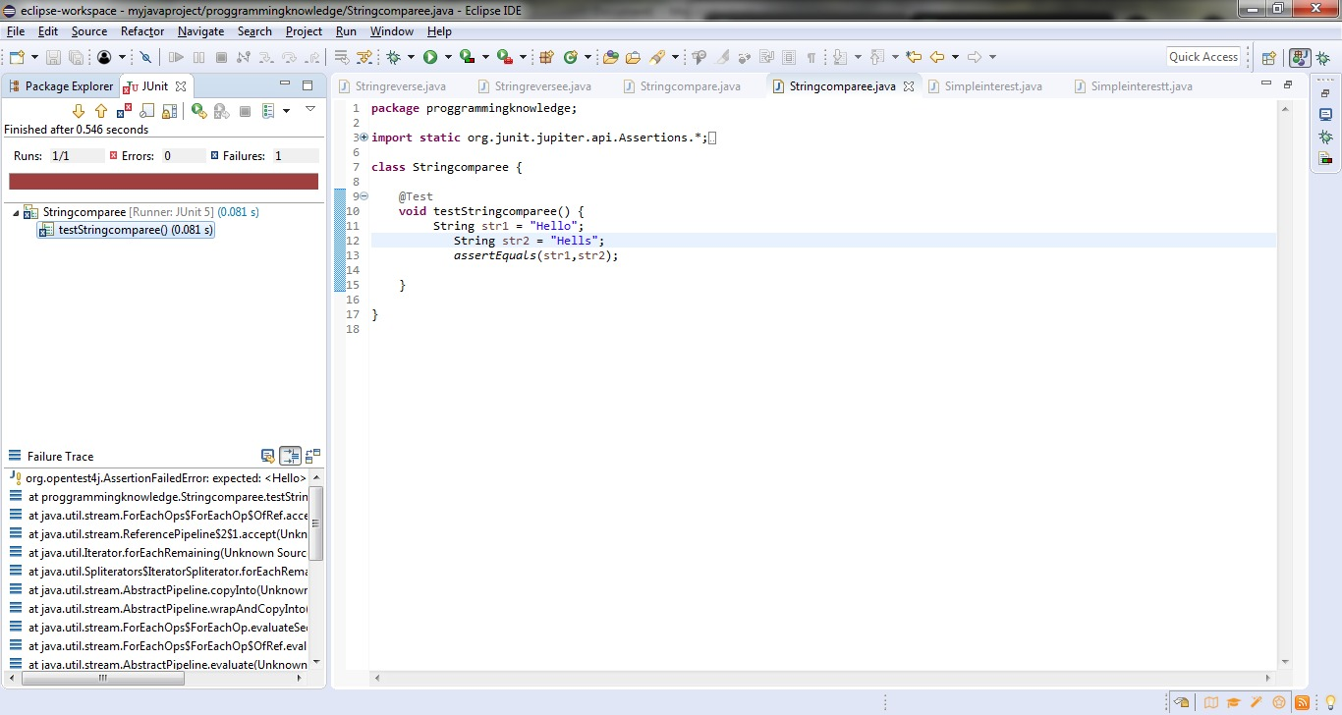

**13.voting system**

package votingsys;

public class vote {

public static String checkEligibility(int age)

{

if (age >= 18) {

return "Eligible for voting";

}

else {

return "Not eligible for voting";

}

}

}

package votingsys;

import static org.junit.jupiter.api.Assertions.*;

import org.junit.jupiter.api.Test;

class voteTest {

@Test

void testEligibleVoter() {

assertEquals("Eligible for voting", vote.checkEligibility(18));

assertEquals("Eligible for voting", vote.checkEligibility(21));

assertEquals("Eligible for voting", vote.checkEligibility(30));

}

@Test

void testNonEligibleVoter() {

assertEquals("Not eligible for voting", vote.checkEligibility(17));

assertEquals("Not eligible for voting", vote.checkEligibility(16));

assertEquals("Not eligible for voting", vote.checkEligibility(12));

}

}

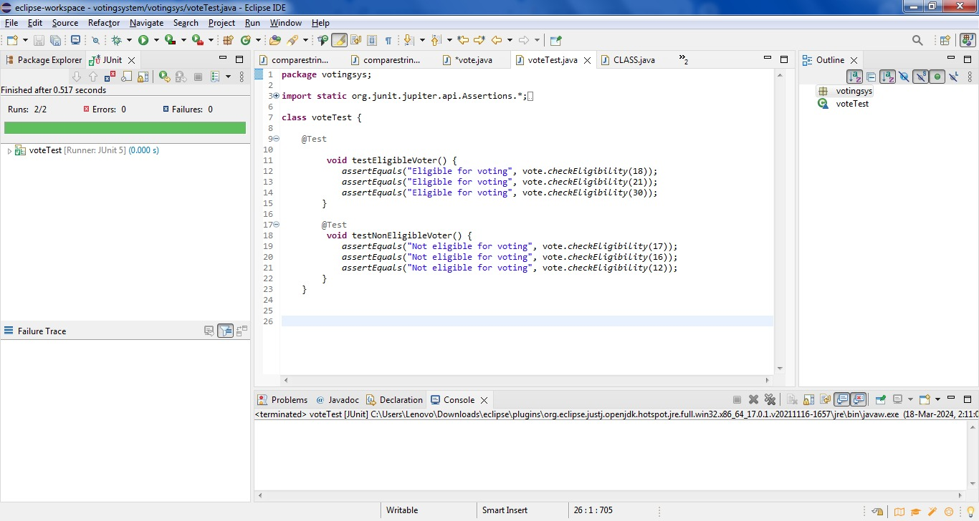

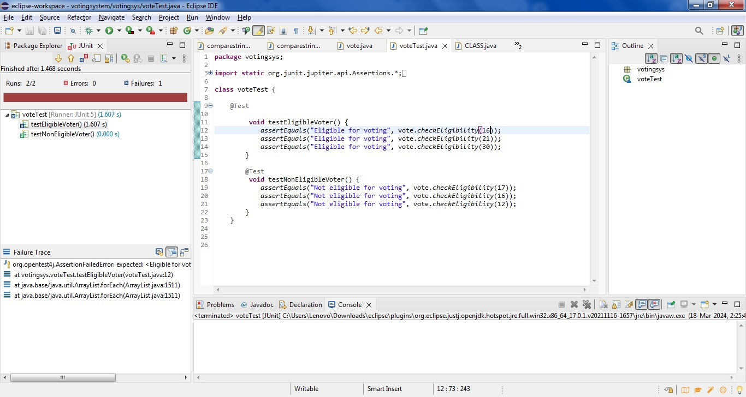

**14.Simple intreset**

**package** simplyintresrtt;

**public** **class** simpleintrest {

**public** **static** **double** calculateSimpleInterest(**double** principal, **double** rate, **double** time) {

**return** (principal * rate * time) / 100.0;

}

}

package simplyintresrtt;

import static org.junit.jupiter.api.Assertions.*;

import org.junit.jupiter.api.Test;

class simpleintrestTest {

@Test

void testCalculateSimpleInterest() {

assertEquals(200.0, simpleintrest.calculateSimpleInterest(1000.0, 5.0, 4.0), 0.01);

assertEquals(450.0, simpleintrest.calculateSimpleInterest(3000.0, 3.0, 5.0), 0.01);

assertEquals(75.0, simpleintrest.calculateSimpleInterest(1500.0, 2.0, 2.5), 0.01);

}}

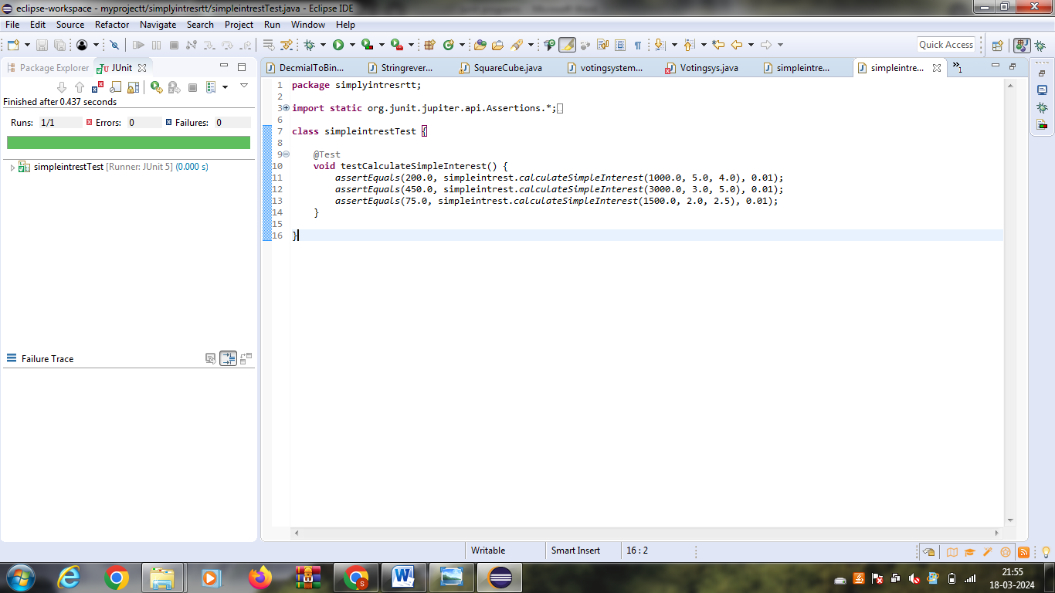

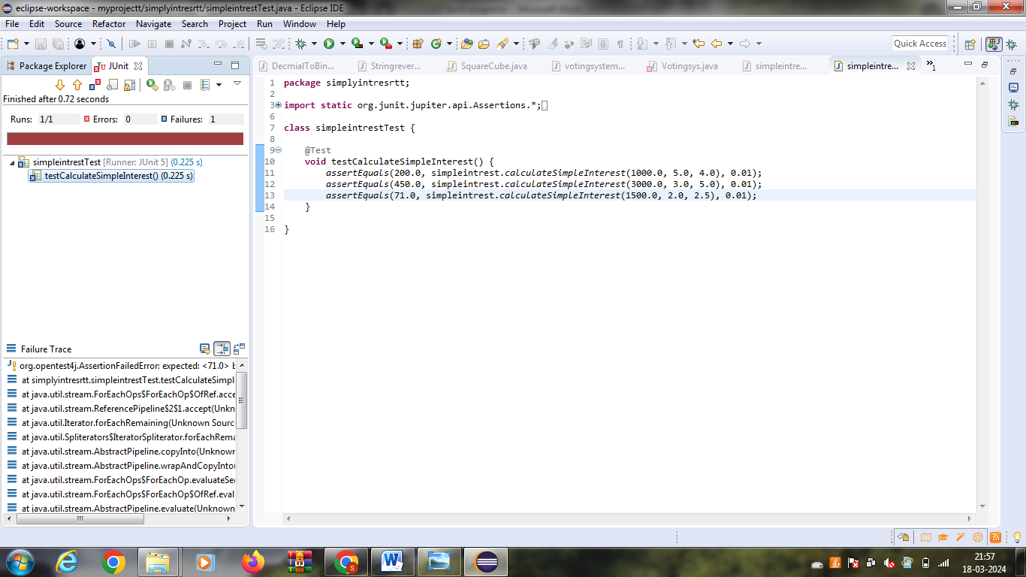

**15.pallindrome**

**package** proggrammingknowledge;

**public** **class** Palindrome {

**public** **static** **void** main(String[] args) {

String str = "radar";

**int** left = 0;

**int** right = str.length() - 1;

**while** (left < right && str.charAt(left) == str.charAt(right)) {

left++;

right--;

}

**if** (left >= right) {

System.***out***.println("Palindrome");

} **else** {

System.***out***.println("Not Palindrome");

}

}

}

package proggrammingknowledge;

import static org.junit.jupiter.api.Assertions.*;

import org.junit.jupiter.api.Test;

class Palindromeornot {

@Test

void testPalindromeornot() {

String str = "radam";

assertTrue(isPalindrome(str));

}

private boolean isPalindrome(String str) {

int left = 0;

int right = str.length() - 1;

while (left < right && str.charAt(left) == str.charAt(right)) {

left++;

right--;

}

return left >= right;

}

**}**

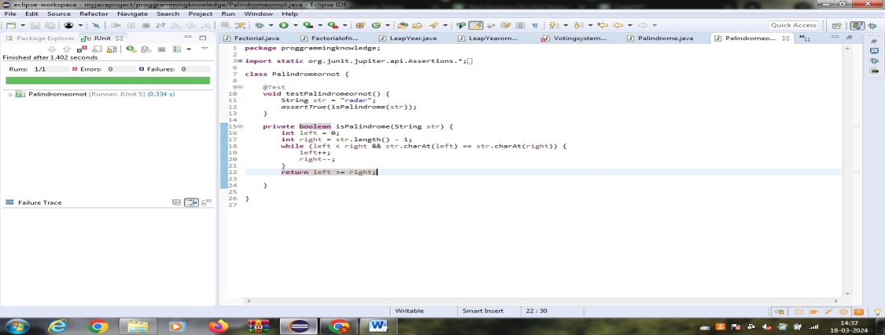

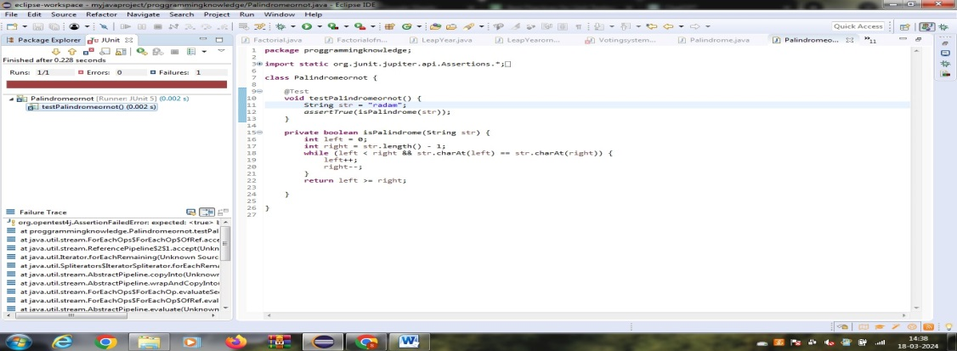

**16.Decimal number to binary and octal**

**package** coding;

**public** **class** NumberConverter {

**public** **static** String decimalToBinary(**int** decimal) {

**return** Integer.*toBinaryString*(decimal);

}

**public** **static** String decimalToOctal(**int** decimal) {

**return** Integer.*toOctalString*(decimal);

}

}

package coding;

import static org.junit.jupiter.api.Assertions.*;

import org.junit.jupiter.api.Test;

class DecmialToBinaryOctal {

@Test

public void testDecimalToBinary() {

int decimal = 10;

String expectedBinary = "1010";

String actualBinary = NumberConverter.decimalToBinary(decimal);

assertEquals(expectedBinary, actualBinary);

}

@Test

public void testDecimalToOctal() {

int decimal = 10;

String expectedOctal = "12";

String actualOctal = NumberConverter.decimalToOctal(decimal);

assertEquals(expectedOctal, actualOctal);

}

}

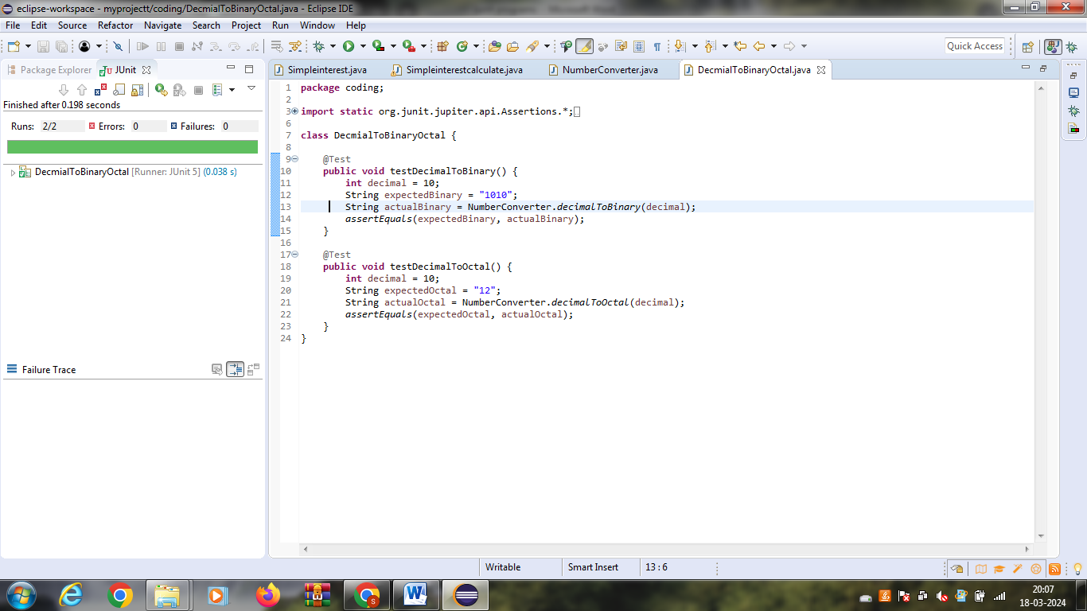

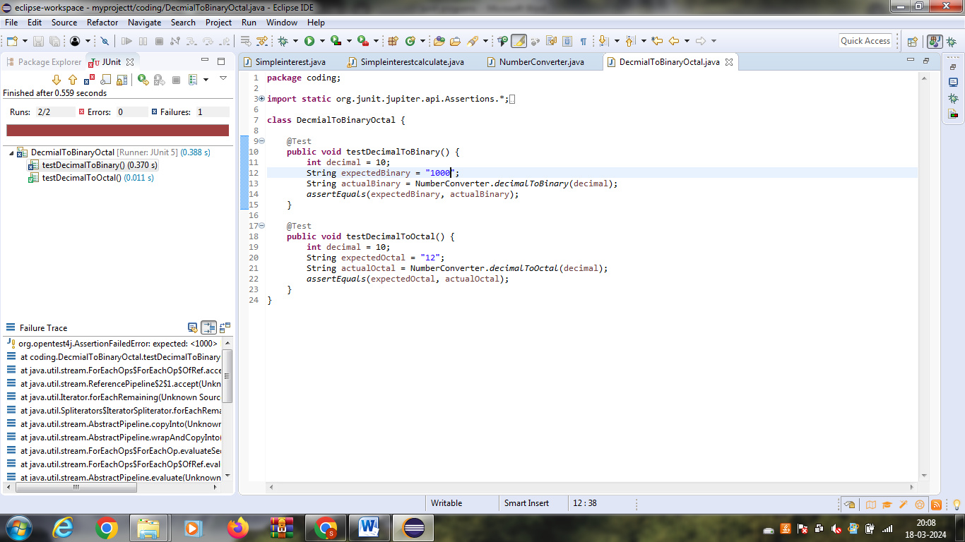

**17.Convert a number of days in terms of years ,weeks and days**

**package** proggrammingknowledge;

**import** java.util.Scanner;

**public** **class** YearsWeeksDays {

**public** **static** **void** main(String[] args) {

Scanner scanner = **new** Scanner(System.***in***);

System.***out***.print("Enter number of days: ");

**int** days = scanner.nextInt();

**int** years = days / 365;

**int** weeks = (days % 365) / 7;

**int** remainingDays = (days % 365) % 7;

System.***out***.println(days + " days is approximately:");

System.***out***.println(years + " years, " + weeks + " weeks, and " + remainingDays + " days.");

}

}

package proggrammingknowledge;

import static org.junit.jupiter.api.Assertions.*;

import org.junit.jupiter.api.Test;

class YearsWeeksDaysconvert {

@Test

void testYearsWeeksDaysconvert() {

int days = 1000;

int years = days / 365;

int weeks = (days % 365) / 7;

int remainingDays = (days % 365) % 7;

assertEquals(2, years);

assertEquals(38, weeks);

assertEquals(4, remainingDays);

}

}

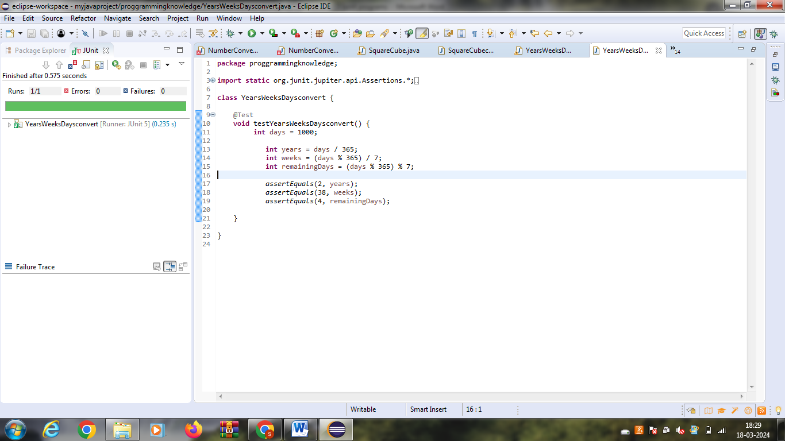

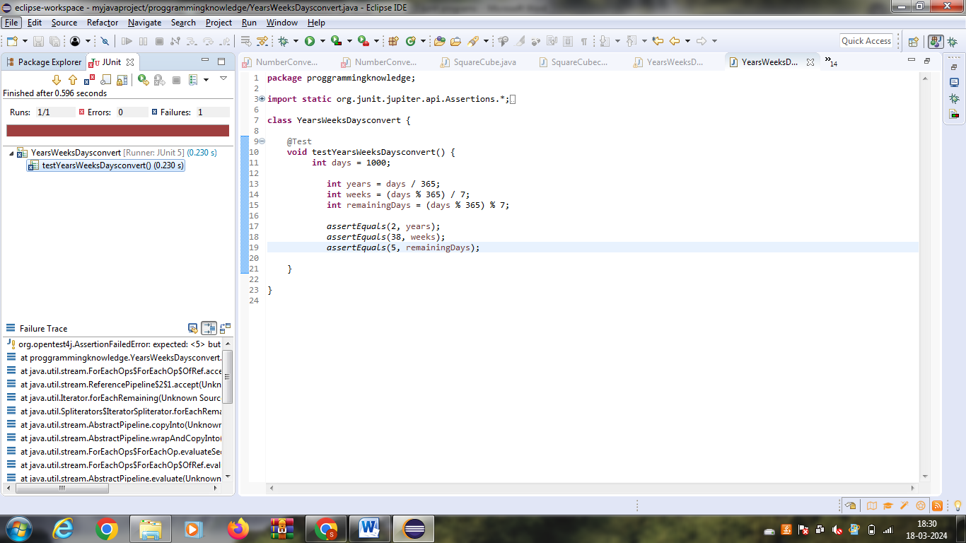

**18.factorial of n**

**package** proggrammingknowledge;

**public** **class** Factorial {

**public** **static** **long** calculateFactorial(**int** n) {

**if** (n < 0) {

**throw** **new** IllegalArgumentException("Factorial is not defined for negative numbers.");

}

**if** (n == 0 || n == 1) {

**return** 1;

}

**long** factorial = 1;

**for** (**int** i = 2; i <= n; i++) {

factorial *= i;

}

**return** factorial;

}

}

package proggrammingknowledge;

import static org.junit.jupiter.api.Assertions.*;

import org.junit.jupiter.api.Test;

class Factorialofn {

@Test

void testFactorialofn() {

assertEquals(1, Factorial.calculateFactorial(0));

assertEquals(1, Factorial.calculateFactorial(1));

assertEquals(120, Factorial.calculateFactorial(5));

assertEquals(3628800, Factorial.calculateFactorial(10));

try {

Factorial.calculateFactorial(-5);

fail("Expected IllegalArgumentException");

} catch (IllegalArgumentException e) {

assertEquals("Factorial is not defined for negative numbers.", e.getMessage());

}

}

}

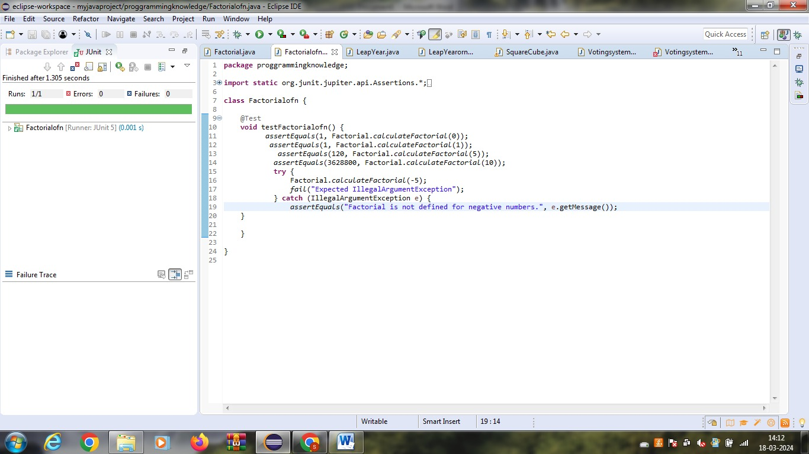

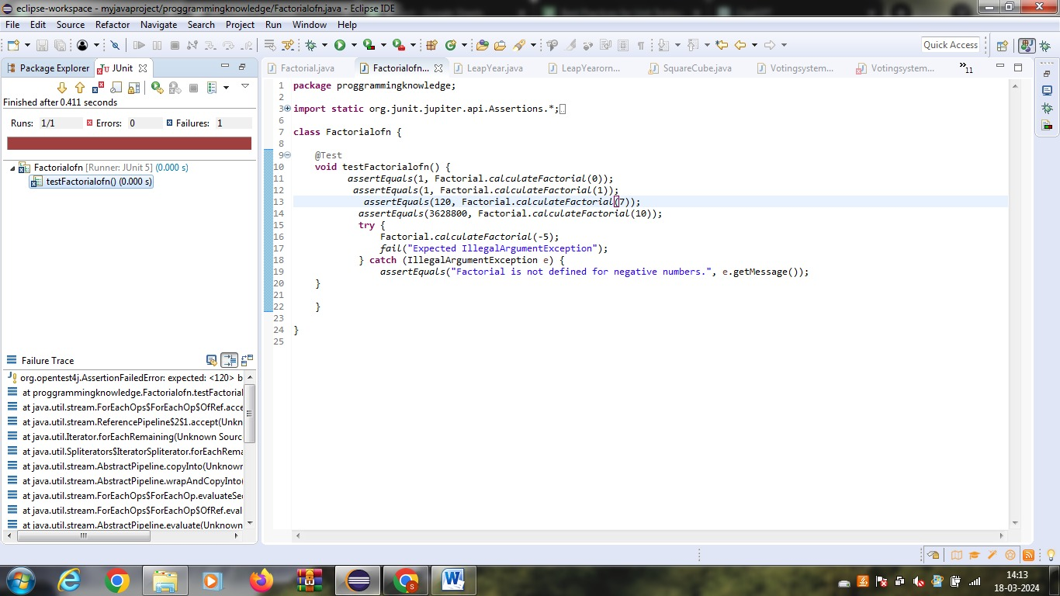

**19.year of the given date is leap year or not**

**package** proggrammingknowledge;

**public** **class** LeapYear {

**public** **static** String checkLeapYear(**int** year) {

**if** ((year % 4 == 0 && year % 100 != 0) || (year % 400 == 0)) {

**return** year + " is a leap year.";

} **else** {

**return** year + " is not a leap year.";

}

}

**public** **static** **void** main(String[] args) {

**int** year = 2024;

System.***out***.println(*checkLeapYear*(year));

}

}

package proggrammingknowledge;

import static org.junit.jupiter.api.Assertions.*;

import org.junit.jupiter.api.Test;

class LeapYearornot {

@Test

void testLeapYearornot() {

assertEquals("2024 is a leap year.", LeapYear.checkLeapYear(2024));

assertEquals("2021 is not a leap year.", LeapYear.checkLeapYear(2021));

assertEquals("2000 is a leap year.", LeapYear.checkLeapYear(2000));

assertEquals("1900 is not a leap year.", LeapYear.checkLeapYear(1900));

}

}

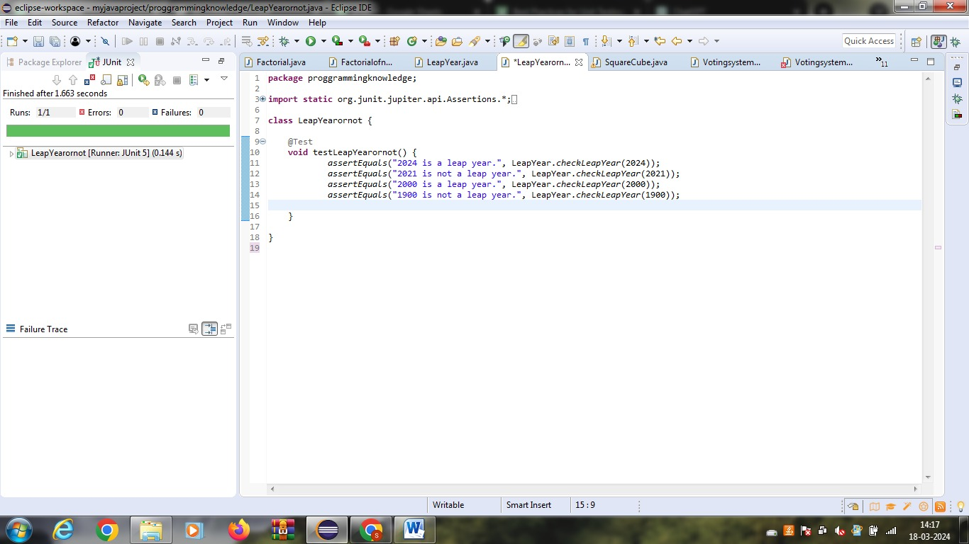

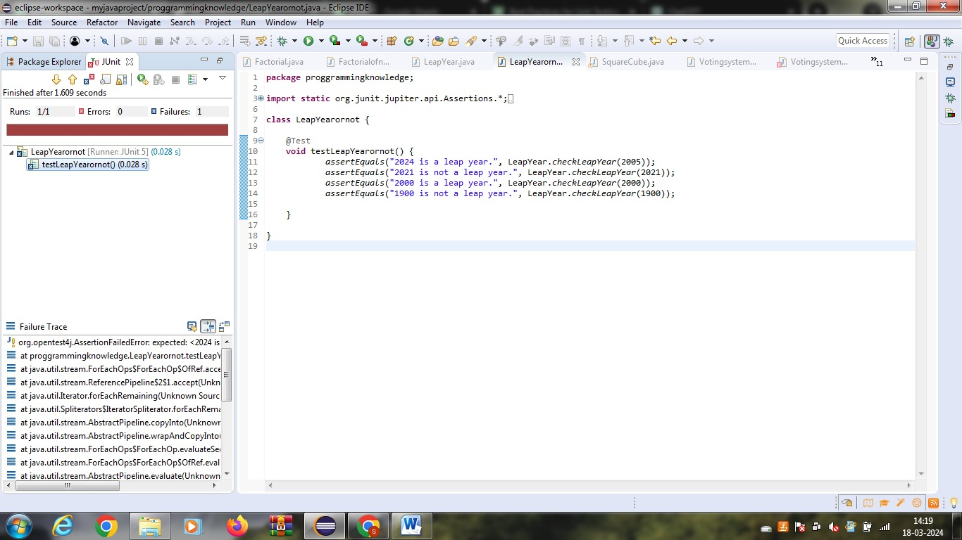

**20.Find the square and cube of the decimal number**

**package** proggrammingknowledge;

**import** java.util.Scanner;

**public** **class** SquareCube {

**public** **static** **void** main(String[] args) {

Scanner scanner = **new** Scanner(System.***in***);

System.***out***.print("Enter a decimal number: ");

**double** number = scanner.nextDouble();

**double** square = number * number;

**double** cube = number * number * number;

System.***out***.println("Square of the number: " + square);

System.***out***.println("Cube of the number: " + cube);

}

}

**package proggrammingknowledge;**

**import static org.junit.jupiter.api.Assertions.*;**

**import org.junit.jupiter.api.Test;**

**class SquareCubeconvert {**

**@Test**

**void testSquareCubeconvert() {**

**double number = 2.5;**

**double square = number * number;**

**double cube = number * number * number;**

**assertEquals(square, 6.25, 0.0001);**

**assertEquals(cube, 15.625, 0.0001);**

**}**

**}**

